**Lab 6 *– My Details***

**Layout Code**

<?xml version="1.0" encoding="utf-8"?>  
<android.support.constraint.ConstraintLayout xmlns:android="http://schemas.android.com/apk/res/android"  
 xmlns:app="http://schemas.android.com/apk/res-auto"  
 xmlns:tools="http://schemas.android.com/tools"  
 android:layout_width="match_parent"  
 android:layout_height="match_parent"  
 tools:context=".MainActivity">  
  
 <ImageView  
 android:id="@+id/imageView"  
 android:layout_width="wrap_content"  
 android:layout_height="wrap_content"  
 android:contentDescription="@string/user"  
 android:scaleType="centerCrop"  
 app:layout_constraintEnd_toEndOf="parent"  
 app:layout_constraintStart_toStartOf="parent"  
 app:layout_constraintTop_toTopOf="parent"  
 app:srcCompat="@drawable/user_bg" />  
  
 <RadioGroup  
 android:id="@+id/radioGroup"  
 android:layout_width="187dp"  
 android:layout_height="147dp"  
 android:layout_marginStart="32dp"  
 android:layout_marginLeft="32dp"  
 android:layout_marginEnd="65dp"  
 android:layout_marginRight="65dp"  
 app:layout_constraintBottom_toBottomOf="parent"  
 app:layout_constraintEnd_toEndOf="parent"  
 app:layout_constraintStart_toEndOf="@+id/textView2"  
 app:layout_constraintTop_toTopOf="parent">  
  
 <RadioButton  
 android:id="@+id/rb1"  
 android:layout_width="match_parent"  
 android:layout_height="wrap_content"  
 android:paddingTop="8sp"  
 android:paddingBottom="8sp"  
 android:text="@string/_18_21"  
 android:textSize="24sp" />  
  
 <RadioButton  
 android:id="@+id/rb2"  
 android:layout_width="match_parent"  
 android:layout_height="wrap_content"  
 android:paddingTop="8sp"  
 android:paddingBottom="8sp"  
 android:text="@string/_22_30"  
 android:textSize="24sp" />  
  
 <RadioButton  
 android:id="@+id/rb3"  
 android:layout_width="match_parent"  
 android:layout_height="wrap_content"  
 android:paddingTop="8sp"  
 android:paddingBottom="8sp"  
 android:text="@string/_31_50"  
 android:textSize="24sp" />  
 </RadioGroup>  
  
 <TextView  
 android:id="@+id/textView"  
 android:layout_width="wrap_content"  
 android:layout_height="29dp"  
 android:text="@string/name"  
 android:textAppearance="@style/TextAppearance.AppCompat.Large"  
 android:textSize="24sp"  
 android:textStyle="bold"  
 app:layout_constraintBottom_toBottomOf="parent"  
 app:layout_constraintEnd_toStartOf="@+id/userName"  
 app:layout_constraintHorizontal_bias="0.814"  
 app:layout_constraintStart_toStartOf="parent"  
 app:layout_constraintTop_toTopOf="parent"  
 app:layout_constraintVertical_bias="0.335" />  
  
 <EditText  
 android:id="@+id/userName"  
 android:layout_width="228dp"  
 android:layout_height="53dp"  
 android:autofillHints=""  
 android:ems="10"  
 android:hint="@string/enter_your_name"  
 android:inputType="textPersonName"  
 android:textAppearance="@style/TextAppearance.AppCompat.Large"  
 android:textSize="24sp"  
 app:layout_constraintBottom_toBottomOf="parent"  
 app:layout_constraintEnd_toEndOf="parent"  
 app:layout_constraintHorizontal_bias="0.951"  
 app:layout_constraintStart_toStartOf="parent"  
 app:layout_constraintTop_toTopOf="parent"  
 app:layout_constraintVertical_bias="0.332" />  
  
 <TextView  
 android:id="@+id/textView2"  
 android:layout_width="61dp"  
 android:layout_height="37dp"  
 android:layout_marginTop="92dp"  
 android:text="@string/age"  
 android:textAppearance="@style/TextAppearance.AppCompat.Large"  
 android:textSize="24sp"  
 android:textStyle="bold"  
 app:layout_constraintEnd_toEndOf="parent"  
 app:layout_constraintHorizontal_bias="0.24"  
 app:layout_constraintStart_toStartOf="parent"  
 app:layout_constraintTop_toBottomOf="@+id/textView" />  
  
 <TextView  
 android:id="@+id/textView3"  
 android:layout_width="wrap_content"  
 android:layout_height="wrap_content"  
 android:layout_marginTop="124dp"  
 android:text="@string/select_city"  
 android:textAppearance="@style/TextAppearance.AppCompat.Large"  
 android:textSize="24sp"  
 android:textStyle="bold"  
 app:layout_constraintEnd_toEndOf="parent"  
 app:layout_constraintHorizontal_bias="0.049"  
 app:layout_constraintStart_toStartOf="parent"  
 app:layout_constraintTop_toBottomOf="@+id/textView2" />  
  
 <CheckBox  
 android:id="@+id/cbDelhi"  
 android:layout_width="wrap_content"  
 android:layout_height="wrap_content"  
 android:layout_marginTop="16dp"  
 android:layout_marginBottom="8dp"  
 android:text="@string/delhi"  
 android:textSize="24sp"  
 app:layout_constraintBottom_toTopOf="@+id/cbMumbai"  
 app:layout_constraintEnd_toEndOf="parent"  
 app:layout_constraintHorizontal_bias="0.102"  
 app:layout_constraintStart_toEndOf="@+id/textView3"  
 app:layout_constraintTop_toBottomOf="@+id/radioGroup" />  
  
 <CheckBox  
 android:id="@+id/cbMumbai"  
 android:layout_width="wrap_content"  
 android:layout_height="wrap_content"  
 android:layout_marginTop="8dp"  
 android:layout_marginBottom="8dp"  
 android:text="@string/mumbai"  
 android:textSize="24sp"  
 android:textStyle="normal"  
 app:layout_constraintBottom_toTopOf="@+id/cbKolkata"  
 app:layout_constraintEnd_toEndOf="parent"  
 app:layout_constraintHorizontal_bias="0.127"  
 app:layout_constraintStart_toEndOf="@+id/textView3"  
 app:layout_constraintTop_toBottomOf="@+id/cbDelhi" />  
  
 <CheckBox  
 android:id="@+id/cbKolkata"  
 android:layout_width="wrap_content"  
 android:layout_height="wrap_content"  
 android:layout_marginTop="8dp"  
 android:layout_marginBottom="8dp"  
 android:text="@string/kolkata"  
 android:textSize="24sp"  
 app:layout_constraintBottom_toTopOf="@+id/cbBanglore"  
 app:layout_constraintEnd_toEndOf="parent"  
 app:layout_constraintHorizontal_bias="0.121"  
 app:layout_constraintStart_toEndOf="@+id/textView3"  
 app:layout_constraintTop_toBottomOf="@+id/cbMumbai" />  
  
 <CheckBox  
 android:id="@+id/cbBanglore"  
 android:layout_width="wrap_content"  
 android:layout_height="wrap_content"  
 android:layout_marginTop="8dp"  
 android:layout_marginBottom="122dp"  
 android:text="@string/banglore"  
 android:textSize="24sp"  
 app:layout_constraintBottom_toBottomOf="parent"  
 app:layout_constraintEnd_toEndOf="parent"  
 app:layout_constraintHorizontal_bias="0.141"  
 app:layout_constraintStart_toEndOf="@+id/textView3"  
 app:layout_constraintTop_toBottomOf="@+id/cbKolkata" />  
  
 <Button  
 android:id="@+id/btnShow"  
 android:layout_width="115dp"  
 android:layout_height="56dp"  
 android:layout_marginStart="162dp"  
 android:layout_marginLeft="162dp"  
 android:layout_marginTop="23dp"  
 android:layout_marginEnd="157dp"  
 android:layout_marginRight="157dp"  
 android:fadingEdge="horizontal|vertical"  
 android:text="@string/show"  
 android:textSize="24sp"  
 android:textStyle="bold"  
 app:layout_constraintBottom_toBottomOf="parent"  
 app:layout_constraintEnd_toEndOf="parent"  
 app:layout_constraintHorizontal_bias="0.5"  
 app:layout_constraintStart_toStartOf="parent"  
 app:layout_constraintTop_toBottomOf="@+id/cbBanglore"  
 app:layout_constraintVertical_bias="0.023" />  
</android.support.constraint.ConstraintLayout>

**JAVA Code**

package com.example.mydetails;  
  
import android.support.v7.app.AppCompatActivity;  
import android.os.Bundle;  
import android.view.View;  
import android.widget.Button;  
import android.widget.CheckBox;  
import android.widget.EditText;  
import android.widget.RadioGroup;  
import android.widget.Toast;  
  
public class MainActivity extends AppCompatActivity {  
  
 private EditText uName;  
 private RadioGroup radioGroup;  
 private CheckBox cDelhi,cMumbai,cKolkata,cBanglore;  
 private Button show;  
  
 @Override  
 protected void onCreate(Bundle savedInstanceState) {  
 super.onCreate(savedInstanceState);  
 setContentView(R.layout.*activity_main*);  
  
 show = findViewById(R.id.*btnShow*);  
  
 uName = findViewById(R.id.*userName*);  
 radioGroup = findViewById(R.id.*radioGroup*);  
 cDelhi = findViewById(R.id.*cbDelhi*);  
 cMumbai = findViewById(R.id.*cbMumbai*);  
 cKolkata = findViewById(R.id.*cbKolkata*);  
 cBanglore = findViewById(R.id.*cbBanglore*);  
  
 show.setOnClickListener(new View.OnClickListener() {  
 @Override  
 public void onClick(View v) {  
 StringBuffer displayMsg = new StringBuffer();  
 displayMsg.append("Username: ");  
 displayMsg.append(uName.getText()).append("\n");  
  
 int selectedRadio = radioGroup.getCheckedRadioButtonId();  
 Button ageButton = findViewById(selectedRadio);  
 if(selectedRadio == -1){  
 Toast.*makeText*(MainActivity.this, "Please select only one age group",Toast.*LENGTH_LONG*).show();  
 }  
 else{  
 displayMsg.append("Age Group: ");  
 displayMsg.append(ageButton.getText()).append("\n");  
 }  
 displayMsg.append("Selected City: ");  
 if(cDelhi.isChecked()){  
 displayMsg.append(cDelhi.getText());  
 }  
 if(cMumbai.isChecked()){  
 displayMsg.append(", ").append(cMumbai.getText());  
 }  
 if(cKolkata.isChecked()){  
 displayMsg.append(", ").append(cKolkata.getText());  
 }  
 if(cBanglore.isChecked()){  
 displayMsg.append(", ").append(cBanglore.getText());  
 }  
  
 Toast.*makeText*(MainActivity.this, displayMsg,Toast.*LENGTH_LONG*).show();  
 }  
 });  
 }  
}

**Manifest File**

<?xml version="1.0" encoding="utf-8"?>  
<manifest xmlns:android="http://schemas.android.com/apk/res/android"  
 package="com.example.mydetails">  
  
 <application  
 android:allowBackup="true"  
 android:icon="@mipmap/ic_launcher"  
 android:label="@string/app_name"  
 android:roundIcon="@mipmap/ic_launcher_round"  
 android:supportsRtl="true"  
 android:theme="@style/Theme.MyDetails">  
 <activity android:name=".MainActivity">  
 <intent-filter>  
 <action android:name="android.intent.action.MAIN" />  
  
 <category android:name="android.intent.category.LAUNCHER" />  
 </intent-filter>  
 </activity>  
 </application>  
  
</manifest>

**Output Screenshots**

1. **Initial Screen**

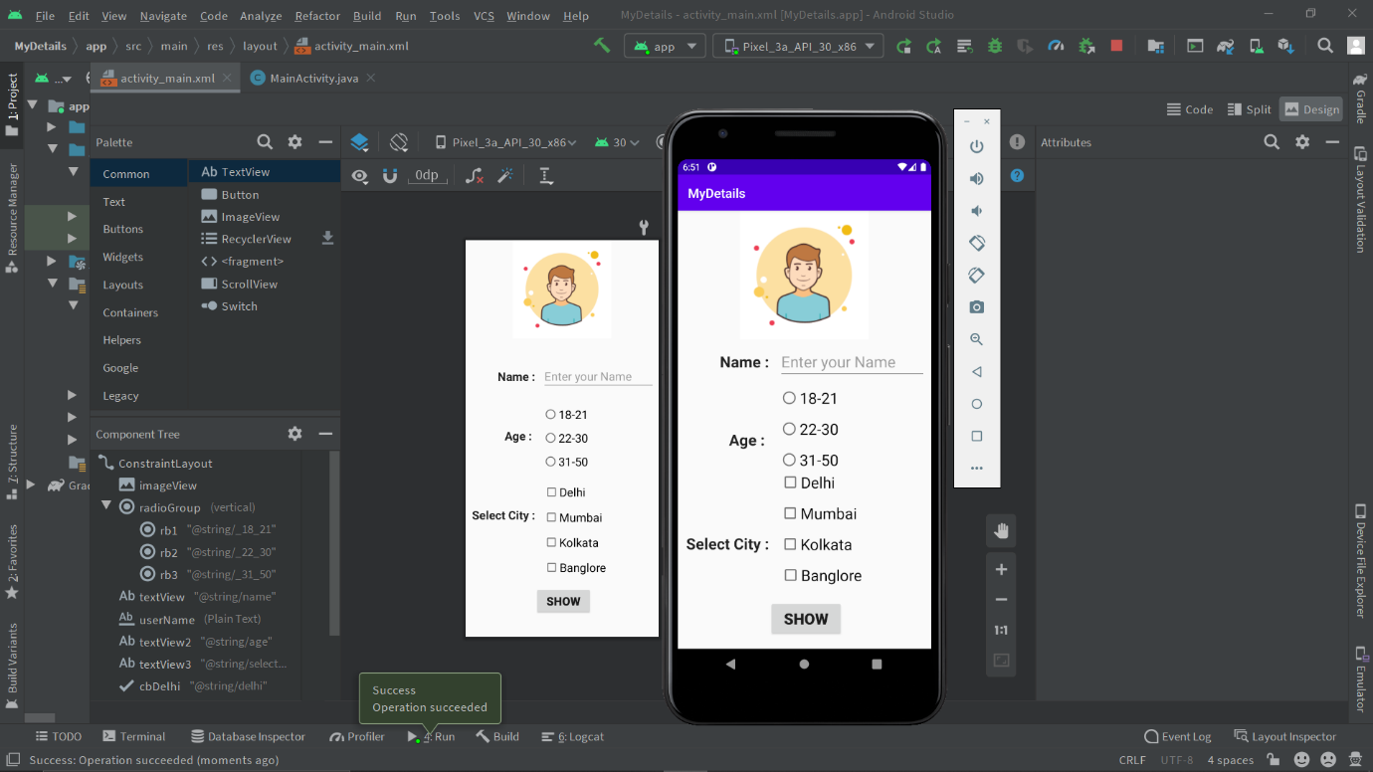

1. **Putting Data and clicking SHOW**

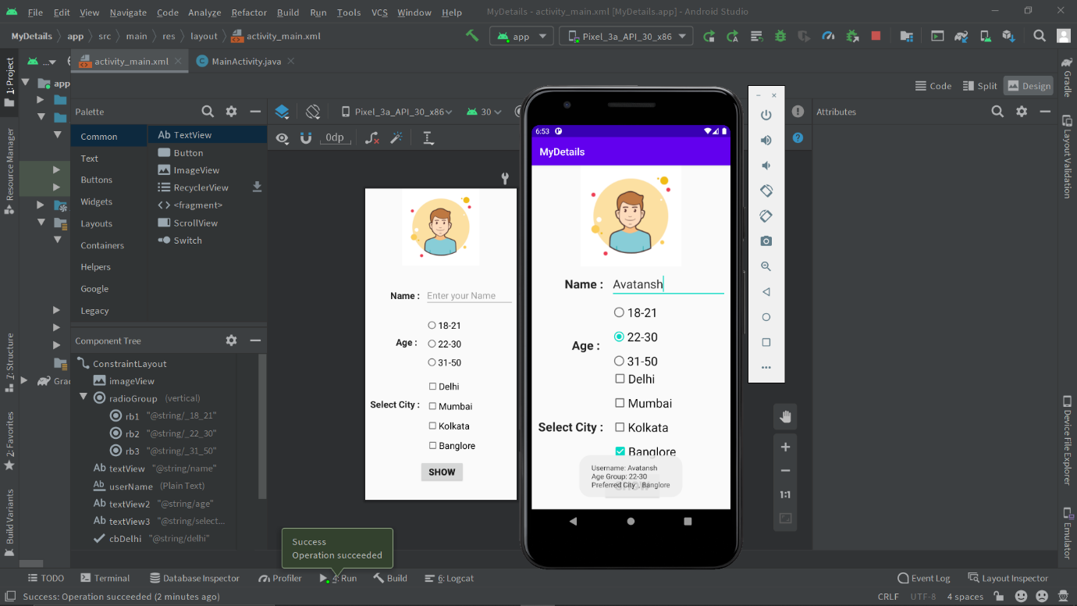

1. **Result for multiple check boxes selection.**

